1. Create a new project in GitHub, click ‘Start a project’

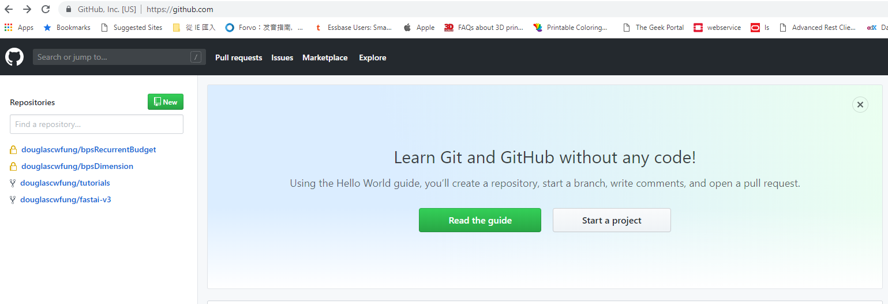

Project name: AgileIntPPMTool

1. In command line run:

git init

git add .

git commit -m "first commit"

git remote add origin https://github.com/douglascwfung/AgileIntPPMTool.git

git push -u origin master